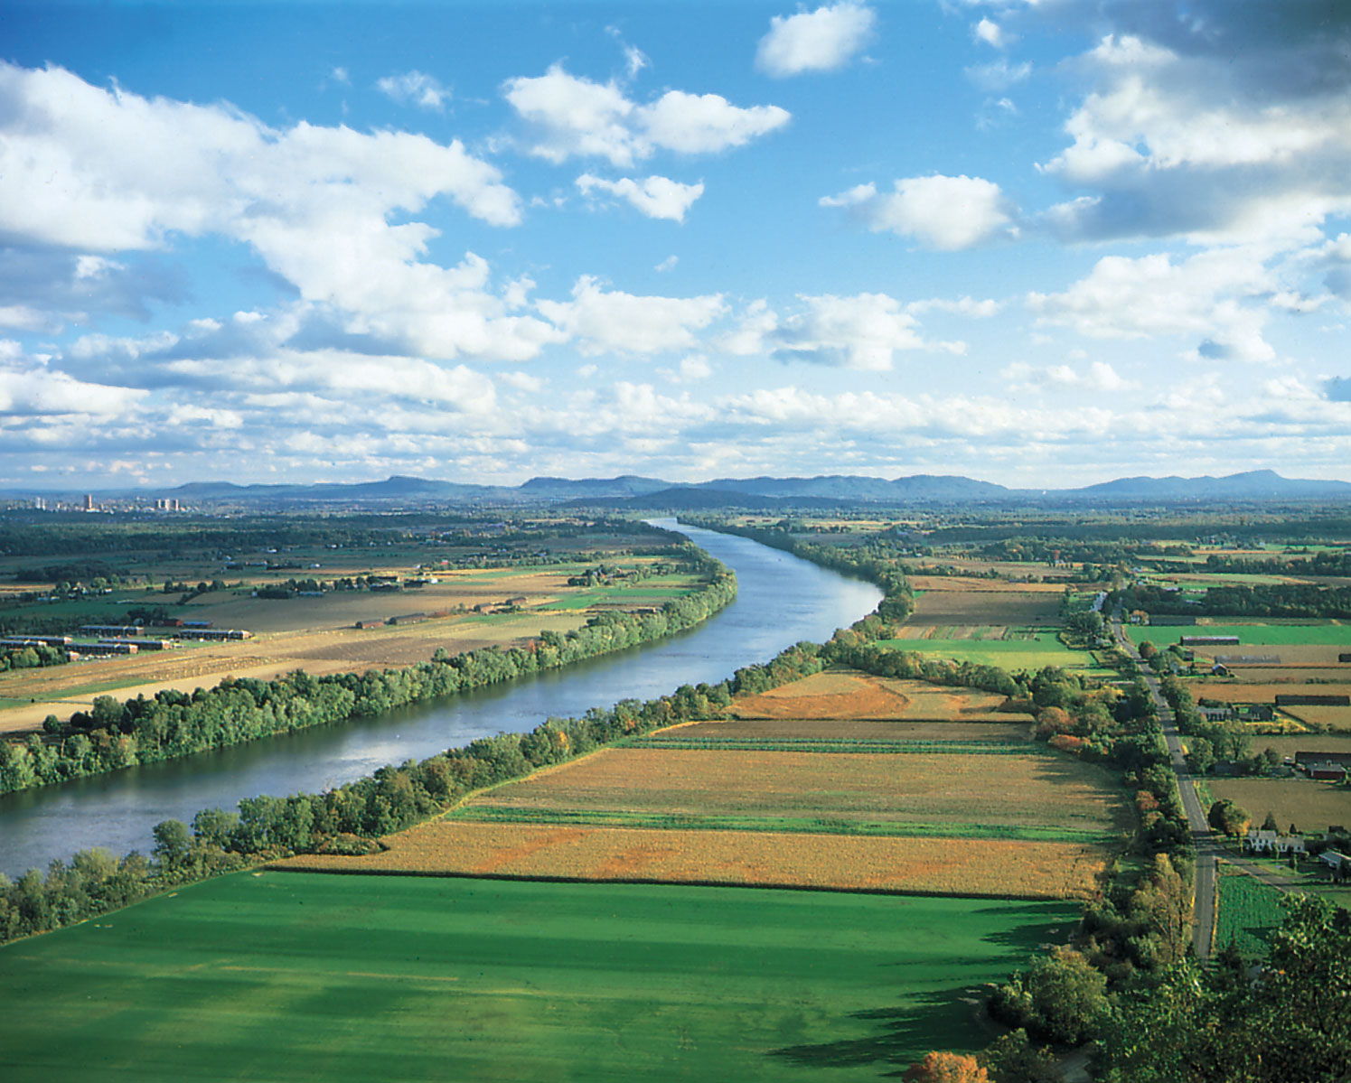

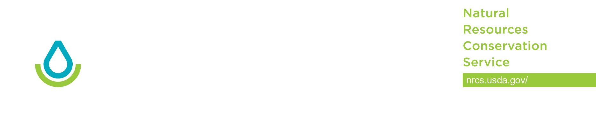

15 August 2019

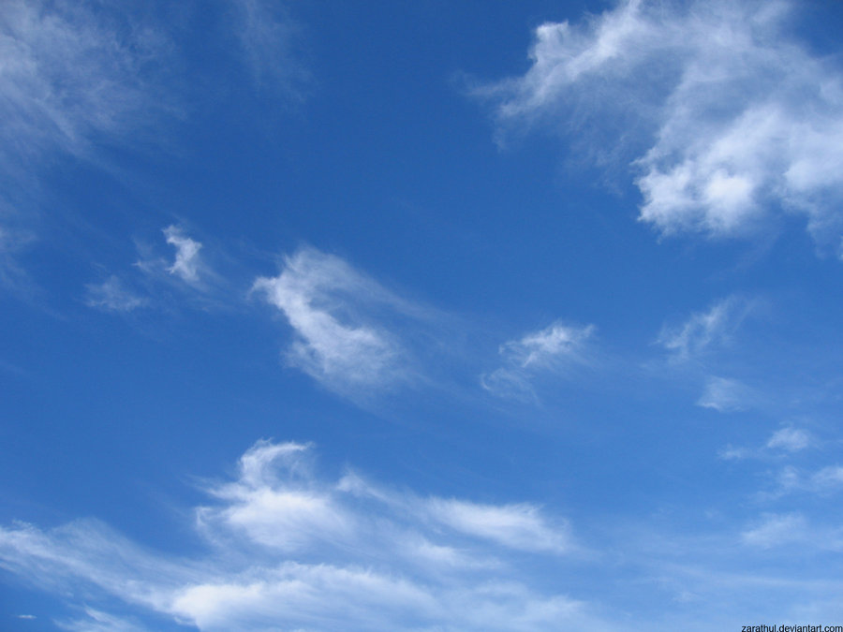

CART Resource Data Service summary

**CONTRIBUTORS**

Marcie Dunn, GIS Specialist, Pennsylvania State Office, Harrisburg, PA

Drew Kinney, Soil Business Systems Leader, National Soil Survey Center, Lincoln, NE

Jason Nemecek, State Soil Scientist, Wisconsin State Office, Madison, WI

Steve Peaslee, GIS Specialist, National Soil Survey Center, Lincoln, NE

Christiane Roy, GIS Specialist, Minnesota State Office, Rochester, MN

Reed Sims, GIS Specialist, Vermont State Office, Colchester, VT

Pam Thomas, Associate Director, Soil and Plant Science Division, Washington, DC

Chad Volkman, GIS Specialist, Kansas State Office, Salina, KS

# CART and Resource Data Team Overview

The Conservation Assessment Ranking Tool (CART) is a client and planned land unit decision support tool. A threshold for each identified resource concern is developed which is based on intrinsic site characteristics, such as soils, hydrography, and climate. The assessment then evaluates the benefits of site-specific management to determine when a resource concern is adequately treated. Management credit includes the ways crops are grown and conservation practices that are applied. Management credits are summed and compared to the threshold for existing conditions and planning alternatives. For program ranking purposes, these same points are used as the basis for prioritization, but ranking may be further modified by identified priorities and/or special considerations.

Resource Data Team identified geospatial data needed to analyze resource concerns and determine benchmark conditions both on and offsite.

# Assumptions and Constraints of Resource Data

* The data will drive the streamlining process; the CART application will direct the process.
* All data layers are Feature Layers and serviced on NRCS Geoportal 10.6.1
* Calculations will be a critical component of the datasets. For example, the Soil Vulnerability Index (SVI) can be calculated on live datasets; no need to create a new SVI data layer every year when the soils data is refreshed.
* Data layers are national in scope and can be supplemented with state-specific data layers. For example, State have updated 303d lists, or have state threatened and endangered species lists
* Data will be Versioned once per year to coincide with a new Fiscal year

# Web Service Sources

* Working Lands For Wildlife feature and map services are maintained by the Resource Inventory and Assessment Division (RIAD) on behalf of the Financial Assistance Programs Division (FAPD) and are maintained on NRCS Geoportal.
* Landscape Initiative feature and map services are maintained by the Resource Inventory and Assessment Division (RIAD) on behalf of the Financial Assistance Programs Division (FAPD) and are maintained on NRCS Geoportal.
* External (non-USDA) feature and map services are maintained by the National Geospatial Center of Excellence (NGCE) Geospatial Data Management Branch, Authoritative Data Team.  These services are maintained on the Geodata services environment and are also linked to geoportal.  Both the source URL for geodata services and geoportal are provided in this document for these services.

# GeoPortal 10.6 Feature Service

|  |  |
| --- | --- |
| **WORKING LAND FOR WILDLIFE** | **Feature Service** |
| American Black Duck Priority Area | [WLFW_ABDU_ProjectBndy_PriorityArea](https://gis.sc.egov.usda.gov/portal/home/item.html?id=b34c6e60484844fcb58dcc892e865914) |
| Blandings Turtle Project Boundary | [WLFW_Blandings_ProjectBndy](https://gis.sc.egov.usda.gov/portal/home/item.html?id=6dfbbb24f7dd4e9c947813741a9378d1) |
| Bog Turtle Target Project Boundary | [WLFW_BogTurtle_ProjectBndy](https://gis.sc.egov.usda.gov/portal/home/item.html?id=5e08a94320354db393a34e227b163864) |
| Colorado River Aquatic Species Project Boundary | [WLFW_Colorado_ProjectBndy](https://gis.sc.egov.usda.gov/portal/home/item.html?id=4f550881ee8148f78831d938fa0e04ef) |
| Conasauga River Aquatic Species Project Boundary | [WLFW_Conasauga_ProjectBndy](https://gis.sc.egov.usda.gov/portal/home/item.html?id=8725f89c9a1e464d8a83046cdef35901) |
| Cutthroat Trout Project Boundary and Priority Area | [WLFW_Cutthroat_Trout_ProjectBndy_PriorityArea](https://gis.sc.egov.usda.gov/portal/home/item.html?id=afbc652df64a4a3c9c53c2e0889e9bfa) |
| Eastern Hellbender Priority Area | [WLFW_Eastern_Hellbender_PriorityArea](https://gis.sc.egov.usda.gov/portal/home/item.html?id=cca6b935a7614b82aa745a9c92450799) |
| Eastern Hellbender Project Boundary | [WLFW_Eastern_Hellbender_ProjectBndy](https://gis.sc.egov.usda.gov/portal/home/item.html?id=d4a8972f4844453fa0de1331d6331b7c) |
| Golden Winged Warbler Priority Area | [WLFW_GWWA_PriorityArea](https://gis.sc.egov.usda.gov/portal/home/item.html?id=b06c9ad9ef724689b274e94f3df2a576) |
| Golden Winged Warbler Project Boundary | [WLFW_GWWA_ProjectBndy](https://gis.sc.egov.usda.gov/portal/home/item.html?id=4e3bd8a267b1493e83d51cd02a72ccdd) |
| Gopher Tortoise Priority Area | [WLFW_Gopher_Tortoise_PriorityArea](https://gis.sc.egov.usda.gov/portal/home/item.html?id=0f2f655e0d6d47d4a35fa043bded032b) |
| Gopher Tortoise Project Boundary | [WLFW_Gopher_Tortoise_ProjectBndy](https://gis.sc.egov.usda.gov/portal/home/item.html?id=e176094249f94071b6ba3c7db2f86f50) |
| Grassland Project for Bobwhite Project Boundary | [WLFW_Bobwhite_Grassland_ProjectBndy](https://gis.sc.egov.usda.gov/portal/home/item.html?id=596eea25952b4e48bd6f32a0405f6100) |
| Kenai Peninsula Salmon Project Boundary | [WLFW_Salmon_ProjectBndy](https://gis.sc.egov.usda.gov/portal/home/item.html?id=365c384ee7504f90b00976f490cb648c) |
| Lesser Prairie Chicken Priority Area | [WLFW_LPC_PriorityArea](https://gis.sc.egov.usda.gov/portal/home/item.html?id=325510f274104961a2b6387db99c69d4) |
| Lesser Prairie Chicken Project Boundary | [WLFW_LPC_ProjectBndy](https://gis.sc.egov.usda.gov/portal/home/item.html?id=8a75eafcc8e04f5b8d895e3d57a3f52b) |
| Louisiana Pinesnake Project Boundary | [WLFW_Louisiana_Pinesnake_ProjectBndy](https://gis.sc.egov.usda.gov/portal/home/item.html?id=1dad9d2e8d484b64b4b4b4e6b1c2d9b8) |
| Louisiana Wetland Shorebirds Project Boundary | [WLFW_Louisiana_Wetland_Shorebird_ProjectBndy](https://gis.sc.egov.usda.gov/portal/home/item.html?id=113738d851324665a6d5543d604b072a) |
| Monarch Butterfly Priority Area | [WLFW_Monarch_PriorityArea](https://gis.sc.egov.usda.gov/portal/home/item.html?id=0e60d9f711da45d6b912aa3acaee7786) |
| Monarch Butterfly Project Boundary | [WLFW_Monarch_ProjectBndy](https://gis.sc.egov.usda.gov/portal/home/item.html?id=6b5fa5b1dd614deba1d935b30302f7ba) |
| Nene Priority Area | [WLFW_Nene_PriorityArea](https://gis.sc.egov.usda.gov/portal/home/item.html?id=05cdb3583328460f8cbda4f781f152dc) |
| Nene Project Boundary | [WLFW_Nene_ProjectBndy](https://gis.sc.egov.usda.gov/portal/home/item.html?id=98a6d10354d84c20838aadeba18a1b00) |
| New England Cottontail Project Boundary | [WLFW_NewEngland_Cottontail_ProjectBndy](https://gis.sc.egov.usda.gov/portal/home/item.html?id=c0657242774f4b5cbd322b80335093fd) |
| Northeast Turtles Project Boundary | [WLFW_Northeast_Turtle_ProjectBndy](https://gis.sc.egov.usda.gov/portal/home/item.html?id=a4642a63cf6a488ca533017a0c3caece) |
| Northern Plains Grassland Project Boundary and Priority Area | [WLFW_NP_Grasslands_ProjectBndy](https://gis.sc.egov.usda.gov/portal/home/item.html?id=5a2d3abe1ced4ee68d467bbef6eac8c7) |
| Sage Grouse Priority Priority Area | [WLFW_Sage_Grouse_PriorityArea](https://gis.sc.egov.usda.gov/portal/home/item.html?id=fb112ba2c1264ef59df960791e861fde) |
| Sage Grouse Project Boudnary | [WLFW_Sage_Grouse_ProjectBndy](https://gis.sc.egov.usda.gov/portal/home/item.html?id=41cbeccb9a904c969d7dee240b02a912) |
| Sandhills Project Boundary | [WLFW_Sandhills_ProjectBndy](https://gis.sc.egov.usda.gov/portal/home/item.html?id=00b9ced537ed4b96a4ff7881d0457b81) |
| Savanna Project for Bobwhite Project Boundary | [WLFW_BobWhite_Savana_ProjectBndy](https://gis.sc.egov.usda.gov/portal/home/item.html?id=08bebf6644514e9ba4b7b60a71bd94a6) |
| Southwestern Willow Flycatcher Priority Area | [WLFW_SW_Willow_Flycatcher_PriorityArea](https://gis.sc.egov.usda.gov/portal/home/item.html?id=c0e0b990bfa048858d24f866bbf3cb32) |
| Southwestern Willow Flycatcher Project Boundary | [WLFW_SW_Willow_Flycatcher_ProjectBndy](https://gis.sc.egov.usda.gov/portal/home/item.html?id=15c0c11ab105498896f101be7951a07c) |
| Yazoo Darter Priority Area | [WLFW_Yazoo_ProjectBndy](https://gis.sc.egov.usda.gov/portal/home/item.html?id=24f942cbb4d94d4da05fdc06fe372cb6) |

|  |  |
| --- | --- |
| **LANDSCAPE INITIATIVE** | **Feature Service** |
| Bay-Delta Initiative | [Bay_Delta](https://gis.sc.egov.usda.gov/portal/home/item.html?id=0fee524e84b24637a77662a0eb5fe302) |
| Chesapeak Bay Initiative (CWBI) | [CBWI](https://gis.sc.egov.usda.gov/portal/home/item.html?id=04a31b6897ee4a5e89fc36270b95f47e) |
| Great Lakes Restoration Initiative | [GLRI_NRCS_Initiative_2019](https://gis.sc.egov.usda.gov/portal/home/item.html?id=3a866614b4f648cbb85b826426d123f2) |
| Great Lakes HUC8 Priority | [GLRI_HUC8_Priority](https://gis.sc.egov.usda.gov/portal/home/item.html?id=7deb8778fa064bd7a473626111169914) |
| Great Lakes Phosphorous Priority | [GLRI_HUC12_Phosphorus_Priority](https://gis.sc.egov.usda.gov/portal/home/item.html?id=470ba7a8fa294d2c8a602fc31273a68c) |
| Gulf of Mexico Initiative | [Gulf_of_Mexico_Initiative](https://gis.sc.egov.usda.gov/portal/home/item.html?id=66bf3f7f2169456e8744feb5807afd09) |
| Illinois River and Eucha-Spavanaw Lake Initiative | [Illinois_River_Eucha](https://gis.sc.egov.usda.gov/portal/home/item.html?id=5b910be5b32d466eb90735573621fb8e) |
| Joint Chief Projects | [Joint Chief Projects](https://gis.sc.egov.usda.gov/portal/home/item.html?id=42fa25ac04a046a58c96c59df6160e5d) |
| Longleaf Pine Initiative | [Longleaf Pine](https://gis.sc.egov.usda.gov/portal/home/item.html?id=cf1851d48acf45ee98b373822bc01913) |
| Mississippi River Basin Healthy Watersheds Initiative | [MRBI](https://gis.sc.egov.usda.gov/portal/home/item.html?id=064aab6fa9e3448abaa711e51403f69f) |
| Northeast Forestry Initiative | [NE Forestry Initiative](https://gis.sc.egov.usda.gov/portal/home/item.html?id=ef085519513c41118a73a3bd7b66533d) |
| NWQI Watersheds City Features | [NWQI_Project_FY19_City_Feature](https://gis.sc.egov.usda.gov/portal/home/item.html?id=2aa4c037d9eb42569090c0e2eacb443a) |
| NWQI Watersheds Features | [NWQI_FY19_Wshd_Feature](https://gis.sc.egov.usda.gov/portal/home/item.html?id=0350c027a7524ce7908f1afbc002478d) |
| Ogallala Aquifer Initiative | [Ogallala Aquifer Initiative](https://gis.sc.egov.usda.gov/portal/home/item.html?id=4e2e757a77814ea1a52f08a6f5e6c425) |
| Red River Basin Initiative | [Red River Basin](https://gis.sc.egov.usda.gov/portal/home/item.html?id=06c04fb593d143dca883f25f3ab11224) |

|  |
| --- |
| **EXTERNAL (NON-USDA) DATA SETS** |
| [USGS National Hydrography Database (NHD)](https://gis.sc.egov.usda.gov/portal/home/item.html?id=76bd033b3995425cb4415ce3ed144a2f) <https://gis.sc.egov.usda.gov/server/rest/services/Hosted/National_Hydrography_Dataset_(NHD)_Vector_Tiles/VectorTileServer> |
| [FEMA FIRM National Flood Hazard Areas](https://gis.sc.egov.usda.gov/portal/home/item.html?id=194d06d193f24a8cb0fe543bc5e594e6)  <https://geodata.sc.egov.usda.gov/arcgis/rest/services/hazard_site/national_flood_hazard/FeatureServer> |
| EPA PM2.5 1997, 2006, 2012, EPA PM-10 1987, EPA 8-Hour Ozone 1997, 2008, 2015 standard non attainment area.  [Non Attainment Areas](https://gis.sc.egov.usda.gov/portal/home/item.html?id=91a5b32fe7a54c8781fa05ea91d3f87c)  <https://geodata.sc.egov.usda.gov/arcgis/rest/services/air_quality/non_attainment_areas/FeatureServer> |
| NatureServe National Species Dataset  (pending) |
| Critical Habitat Threatened/Endangered Species USFWS ECOS  [USFWS ECOS Critical Habitat](https://gis.sc.egov.usda.gov/portal/home/item.html?id=09dbae8f6ad64d9087fef4be6461ba64)  <https://geodata.sc.egov.usda.gov/arcgis/rest/services/endangered_habitat/usfws_critical_habitat/FeatureServer> |
| EPA 303(d) EPA -area, line, points (last updated 2015. State will have more current versions)  [Impaired Waters](https://gis.sc.egov.usda.gov/portal/home/item.html?id=20a4e6034611426e96fa669d0c437d3f)  <https://geodata.sc.egov.usda.gov/arcgis/rest/services/hydrography/impaired_waters/FeatureServer> |
| [EPA Mandatory Class 1 Federal Areas](https://gis.sc.egov.usda.gov/portal/home/item.html?id=af15afd5ead0417ea8d12e3c1b77da96)  <https://geodata.sc.egov.usda.gov/arcgis/rest/services/government_units/mandatory_class1/FeatureServer> |
| [Coastal Zone Management Counties](https://gis.sc.egov.usda.gov/portal/home/item.html?id=3e5811865b9e431ea251ea0a67f09a83)  <https://geodata.sc.egov.usda.gov/arcgis/rest/services/government_units/coastal_zone_management/FeatureServer> |
| [Coral Reefs](https://gis.sc.egov.usda.gov/portal/home/item.html?id=0fd640257d9e429f95e35a6b4f367e80)  <https://geodata.sc.egov.usda.gov/arcgis/rest/services/land_use_land_cover/coral_reefs/FeatureServer> |
| [National Wetland Inventory Vers2](https://gis.sc.egov.usda.gov/portal/home/item.html?id=e73d7f1542ea4386a47ce23028efb4ff)  <https://geodata.sc.egov.usda.gov/arcgis/rest/services/wetlands/national_wetland_inventory/FeatureServer> |
| [Wild Scenic Rivers lines](https://gis.sc.egov.usda.gov/portal/home/item.html?id=0ca9cc16f1b74b34a2432d2b154a7aa4)  <https://geodata.sc.egov.usda.gov/arcgis/rest/services/hydrography/wild_scenic_rivers/FeatureServer> |
| Protected Areas Database (PAD-US 2.0) Federal, State, Local, NGO, Wilderness Areas, Wildlife Refuges, National Forests, DOI, BLM, USNPS, State Protected Lands and more.  [Protected Areas Database PADUS 2.0](https://gis.sc.egov.usda.gov/portal/home/item.html?id=e3fe71fcda1b4e56a84e7366dd5ddacc)  <https://geodata.sc.egov.usda.gov/arcgis/rest/services/land_use_land_cover/padus/FeatureServer> |
| [National Historic Places](https://gis.sc.egov.usda.gov/portal/home/item.html?id=dfd67a9d9a5242e4a39237eb972806d5)  <https://geodata.sc.egov.usda.gov/arcgis/rest/services/landmarks/national_historic_places/FeatureServer> |
| For Addressing Easement Ranking National Questions  Average Farm Size Per County, Percent change 2012-2017 for Acreage of Farm and Ranch Land Per County and Land used for hay, haylage, grass silage, and greenchop . US Census - Population Density and Percent change by county 2000-2010  [Agcensus County Statistics Feature Service](https://gis.sc.egov.usda.gov/portal/home/item.html?id=45b3b56c554448dea5b70d2ccf9bf5a0)  <https://geodata.sc.egov.usda.gov/arcgis/rest/services/government_units/agcensus_county_statistics/FeatureServer> |
| [NRCS Easement Feature Service](https://gis.sc.egov.usda.gov/portal/home/item.html?id=6066ca5109e34ed89f92780aed680e0b)  <https://geodata.sc.egov.usda.gov/arcgis/rest/services/easements/easements/FeatureServer> |

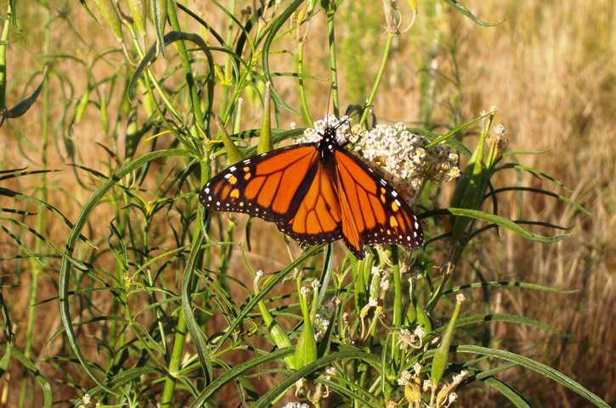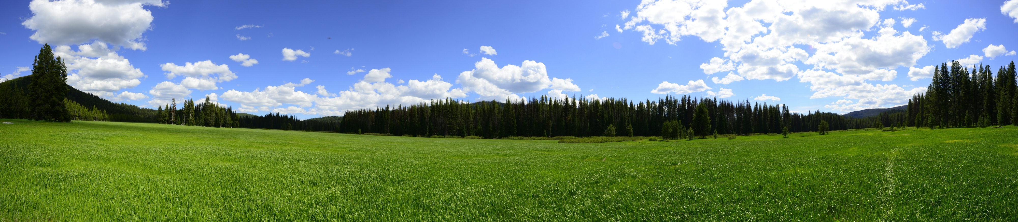

USDA is an equal opportunity provider, employer, and lender.

AUGUST 2019